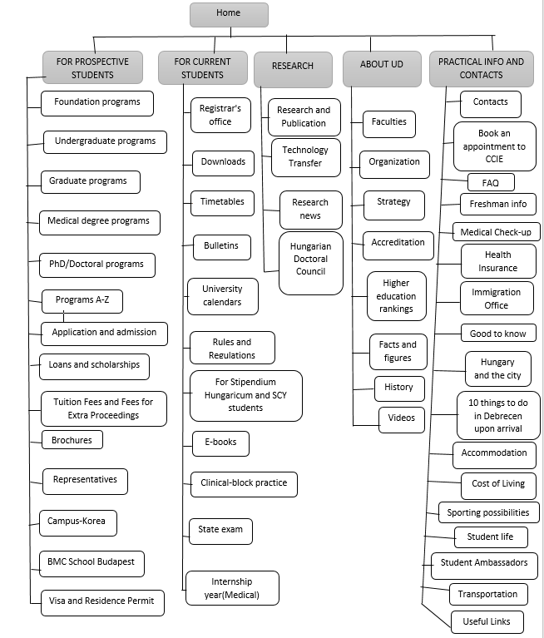

Figure : Site Information Architecture 1

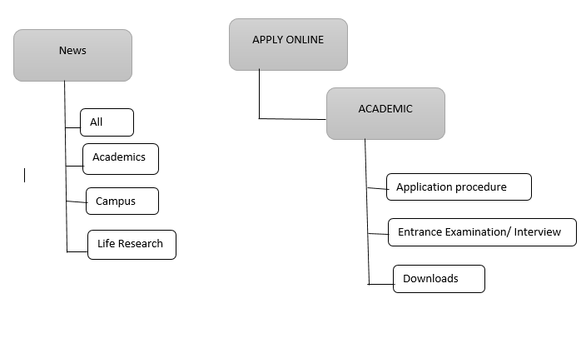
Figure 2 : Site Information Architecture 2

